Types of Routers
# Source: Chatgpt (GPT‑5 Mini) at [12/18/2025]
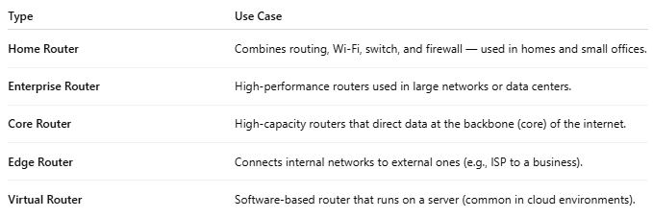

Type | Use Case
Home Router | Combines routing, Wi-Fi, switch, and firewall — used in homes and small offices.
Enterprise Router | High-performance routers used in large networks or data centers.
Core Router | High-capacity routers that direct data at the backbone (core) of the internet.
Edge Router | Connects internal networks to external ones (e.g., ISP to a business).
Virtual Router | Software-based router that runs on a server (common in cloud environments).

